Create and add user in sudo

Create
Sudo useradd <username>
Password -change
Sudo passwd <username>
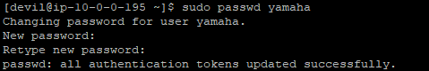
Adding user in sudo group
Sudo usermod -aG wheel <username>


